**Model Development Phase Template**

|  |  |
| --- | --- |
| Date | 01 December 2024 |
| Team ID | 739791 |
| Project Title | Rice Crop Monitoring-Time Series Analysis |
| Maximum Marks | 10 Marks |

**Initial Model Training Code, Model Validation and Evaluation Report**

The initial model training code will be showcased in the future through a screenshot. The model validation and evaluation report will include a summary and training and validation performance metrics for multiple models, presented through respective screenshots.

**Initial Model Training Code (5 marks):**

1. **Arima Model**

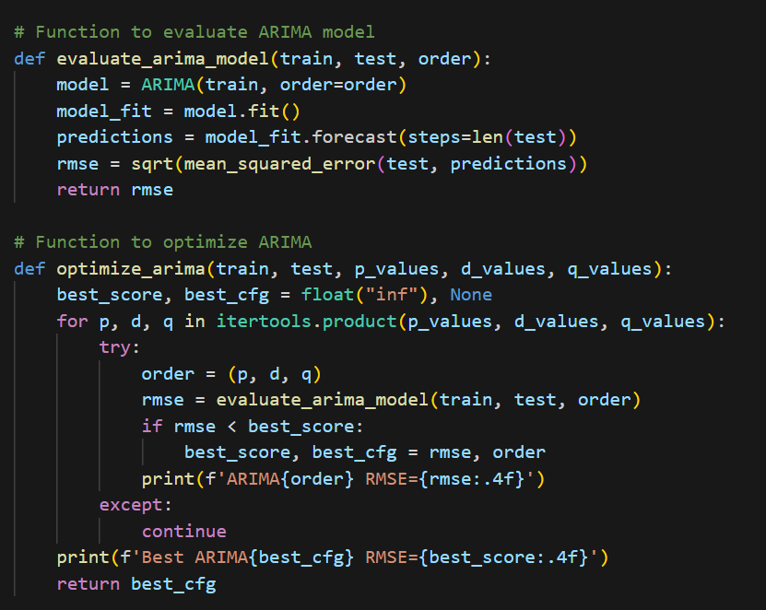

1. Sarima Model

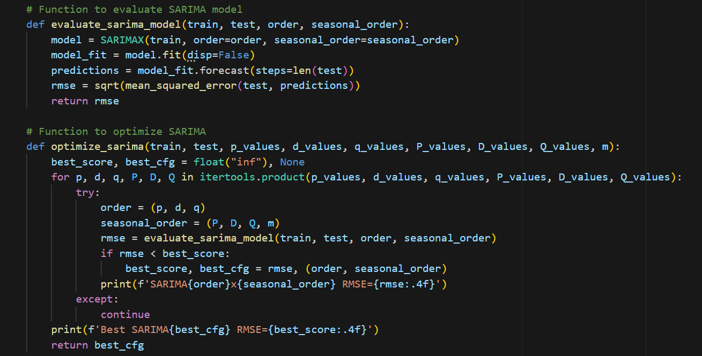

1. Facebook Prophet Model

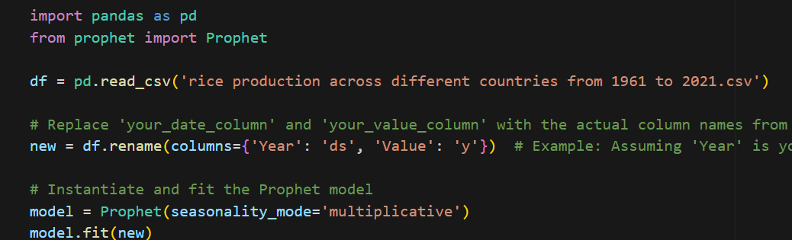

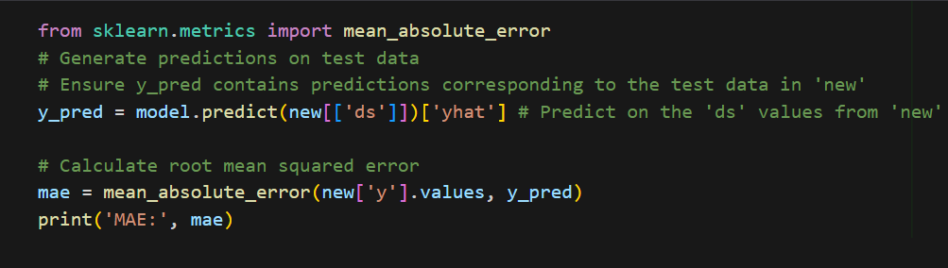

**Model Validation and Evaluation Report (5 marks):**

|  |  |  |
| --- | --- | --- |
| **Model** | **Summary** | **Training and Validation Performance Metrics** |
| Arima Model | * Combines three components:   **AR (AutoRegression),** **I (Integration), MA (Moving Average)**  Requires the time series to be **stationary** (constant mean and variance over time).  **Use Cases:**   * Works well for univariate time series with linear trends and seasonality. * Suitable for short-term forecasting. |  |
| Sarima Model | **2. SARIMAX (Seasonal AutoRegressive Integrated Moving Average with eXogenous factors)**   * Features theExtension of ARIMA   **Use Cases:**   * Best for time series data with **seasonal patterns** (e.g., monthly sales). * Incorporates external variables to improve accuracy. |  |
| Facebook Prophet model | **Features:**   * Developed by Facebook, designed for business forecasting with a focus on **non-statisticians**. * Automatically handles:   Trends (linear or logistic growth),Seasonality (daily, weekly, yearly), Holidays/events as additional regressors.  **Use Cases:**   * Robust for time series with irregular or missing data. * Suitable for datasets with holidays or special events. * Highly customizable and interpretable. |  |